Tugas 1: Analisis Kebutuhan Program untuk Manajemen File

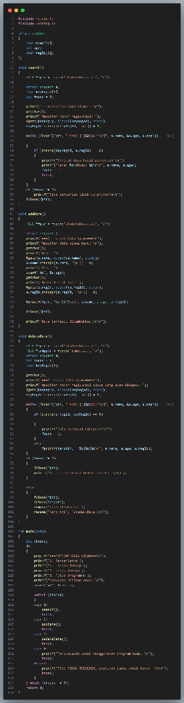

- Buat pseudo code atau flowchart untuk setiap operasi (Tambah, Hapus, Cari).

PSEUDO CODE
Data Structure
DECLARE STRUCT Student
Name (type string)
age (type integer)
regId (type string)
END STRUCT

Procedure Add Data
OPEN or CREATE file "studentData.txt" in append mode
DECLARE STRUCT student a
INPUT name, age, and registration number into struct student a
WRITE a.name, a.age, a.regId to file using "|" as delimiter
DISPLAY data successfully added information
CLOSE file
END

Procedure Search Data
OPEN file "studentData.txt" in read mode
DECLARE STRUCT student a
DECLARE keyword as string
DECLARE found integer = false
INPUT keyword
WHILE not end of file
READ name, age, and registration number from file
IF registration number equals keyword THEN
DISPLAY student data
ASSIGN found = true
EXIT loop
END IF
END WHILE

IF found is false THEN
DISPLAY data not found information
END IF
CLOSE file
END PROCEDURE

Procedure Delete Data
OPEN file "studentData.txt" in read mode
OPEN or CREATE file "temp.txt" in write mode
DECLARE STRUCT student a
DECLARE keyword as string
DECLARE found integer = false
INPUT registration id keyword
WHILE not end of file
READ name, age, and registration number from file
IF registration id equals keyword THEN
DISPLAY data successfully deleted information
ASSIGN found = true
ELSE
WRITE name, age, and registration number (THAT NOT EQUALS WITH KEYWORD) to temp file
END IF
END WHILE
IF found = false
DISPLAY Registration Number not found information
CLOSE studentData.txt
ELSE
DELETE "studentData.txt"
RENAME "temp.txt" to "studentData.txt"
END IF
END FUNCTION

Main Program
START
DECLARE choice as integer

DO
DISPLAY menu options
INPUT choice
SWITCH choice
CASE 1:
CALL SearchData procedure
CASE 2:
CALL AddData procedure
CASE 3:
CALL DeleteData procedure
CASE 0:
DISPLAY exit message
DEFAULT:
DISPLAY invalid menu message
END SWITCH
WHILE choice is not 0
END

FLOW CHART

selection procedure
Search data procedure
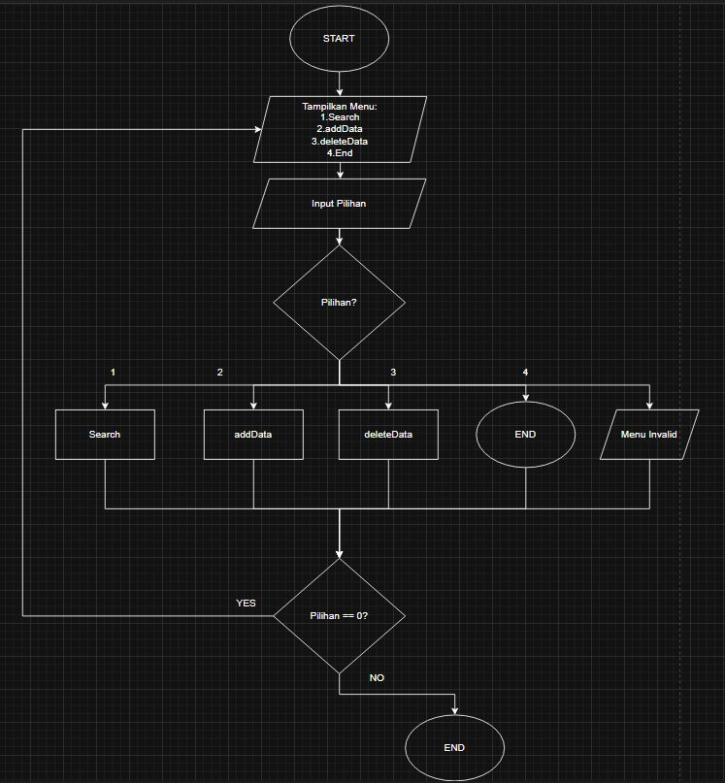
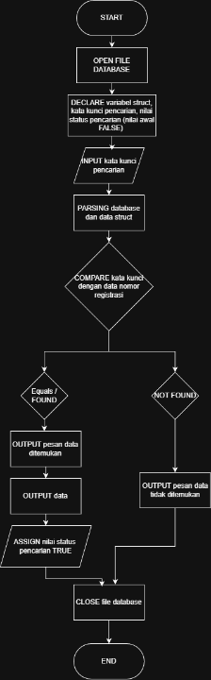

Add data procedure Delete data procedure
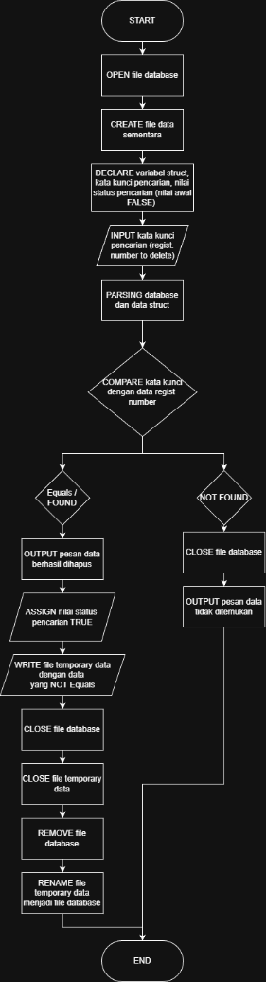
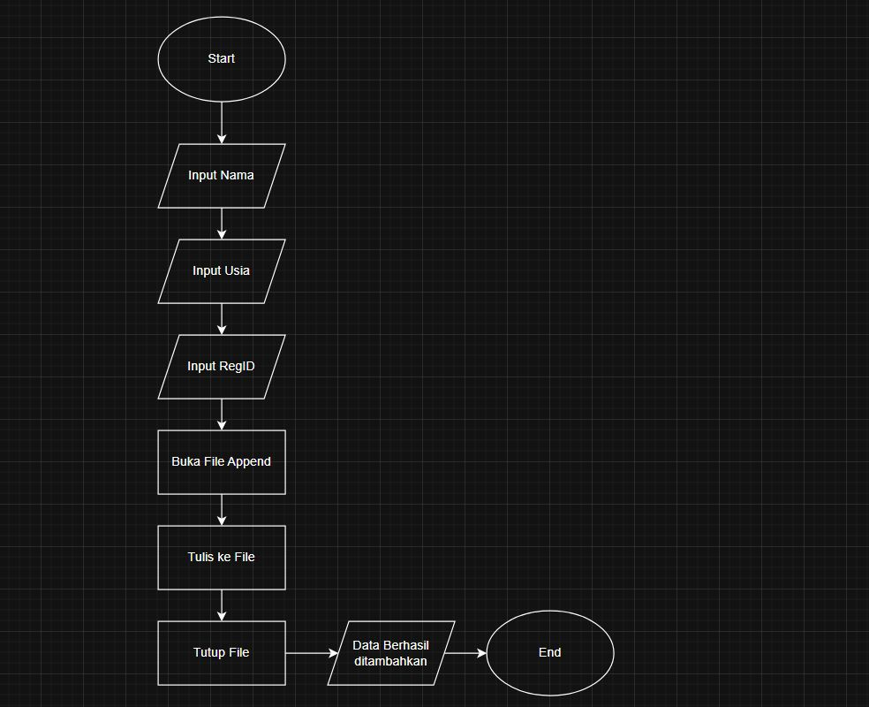

- Jelaskan format file yang dipakai (file teks atau biner, delimiter, format baris).
File untuk menyimpan data menggunakan jenis file teks dengan format .txt. Delimiter untuk memisah jenis data menggunakan simbol karakter “|” (karakter pipa). Sementara data menggunakan format baris dimana setiap satu baris menyimpan satu data siswa.

- Analisis bagaimana program Anda menangani alokasi memori.
Program ini tidak menggunakan alokasi memori dinamis seperti malloc, calloc, dan realloc melainkan menggunakan alokasi memori otomatis (stack). Data dialokasikan secara otomatis pada program saat prosedur dipanggil, dan dilepas secara otomatis saat prosedur selesai dijalankan. Dengan ini program hanya membaca perbaris data setiap iterasi tanpa harus memuat keseluruhan data kedalam memori.

